Ahmed Omar Zein

Ms Aya ElShaer

SCI 8D

9December2022

The modern periodic table is the table where most of the elements that we discovered or created are organized there according to properties, shells, and atomic number, and the old one was by atomic mass. Some people see that this table is well organized and good while others see that we can make some changes to improve it or make a new design, however, there is no doubt that this periodic table is very important for people and scientists. The first periodic table or Mendeleev’s periodic table of 1869 was made up of 17 columns and two nearly complete periods and was arranged by the atomic mass incrementally.

The problem is that Now after we discovered new elements and made or created elements that filled the periodic table from 1950 until now like ( Lr, Rf, Db, Sq, Bh, Hs, Mt, Ds, Rg, Cn, Nh, Fl, Mc, Lv, Ts, Og), and that led scientist to try to design a new periodic table that does not have all the problems of the modern one like that it is fully full, there are elements outside it, there are large gaps, and hydrogen place is not so good as it is with alkali metals but it is a gas that reacts strongly. The new periodic table design or the (Benfey spiral periodic table) will solve some of these problems like the hydrogen place, it has a bigger space for more elements, no elements outside the table, and no big empty spaces.

This new periodic table design will help us add our new element or element x that we had discovered. This element with an atomic number of 125 and all the properties of metals with less cost can enter too many things instead of iron as it is cheaper. Although the Benfey spiral periodic table has more space to add in new elements there are some problems, For example, this periodic table doesn’t give lots of data about the element as it has only the symbol. One another thing is that it does not show the electronic configuration for all of the elements, Also it is a bit hard to follow as there is no atomic number and there are no clear marks to show that this is a group. So adding this element is some kind of hard as also the transition metal part is filled and it has about 3 valance electrons so it is a transition metal.

To solve these problems in the Benfey spiral periodic table there are some changes that we can make across the design to improve it. For example, it can be rearranged to be in a key shape and remove the inner empty part to get a key shape that would be more organized or fill the empty parts with elements from the transition area to make more space above it. Also, the atomic number of each element should be added to each symbol. One another thing is that there are elements that their places should be replaced with other elements, for example, B and Si or C.

One another solution is to also remove the empty part of lanthanides while adding the atomic number. Also, we should make an extra outer line so that some elements could be pushed in it so there is a bigger space for transition metals and the atomic number order is correct and the groups are clearer. Now, after these changes element x can be added in the empty part that will be made after some elements go in the empty part that is written in it transition metals according to the first solution. If the second solution is made so it will be added in the extra line above the transition metals.

The first solution is not so good as the atomic number increscent sequence will be scattered as how 125 is before 99, 100, 102, 103… that is why it will not be a good solution. On the other hand, the second solution is better as it will let the table more organized and the atomic number increscent sequence will be fine and there will be a bigger space for more and more elements that we may discover or create in the future. 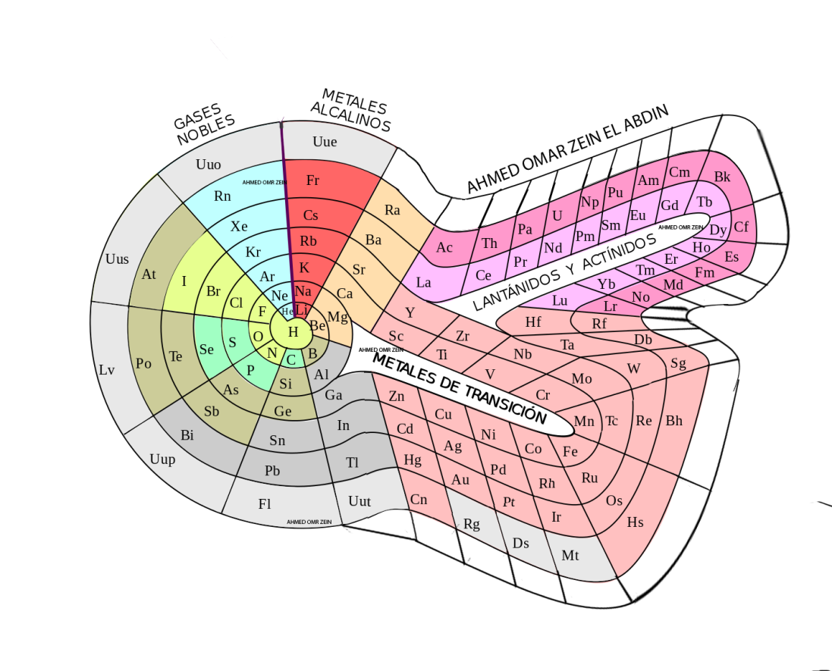

# As a summary, from the Mendeleev periodic table until our modern one all of them have lots of negatives and positives because we are humans and we make mistakes and until now we did not discover or learned lots of things as Allah said (وَيَسْأَلُونَكَ عَنِ الرُّوحِ ۖ قُلِ الرُّوحُ مِنْ أَمْرِ رَبِّي وَمَا أُوتِيتُم مِّنَ الْعِلْمِ إِلَّا قَلِيلًا (85).” I saw in a dream a table where all the elements fell into place as required.” , Dmitri Mendeleev

References:

<https://edu.rsc.org/feature/trouble-in-the-periodic-table/2020266.article>

<https://www.britannica.com/science/periodic-table/The-basis-of-the-periodic-system>

<https://www.asbmb.org/asbmb-today/science/020721/a-brief-history-of-the-periodic-table>

<https://www.rsc.org/periodic-table/history>

<https://sciencestruck.com/history-of-periodic-table>

<https://www.britannica.com/science/periodic-table/The-periodic-table>

<https://pubchem.ncbi.nlm.nih.gov/periodic-table/>

<https://prezi.com/2lzfcnc-c1tn/theodor-benfeys-spiral-periodic-table-1964/>

<https://quran.ksu.edu.sa/tafseer/tabary/sura17-aya85.html>

<https://pubchem.ncbi.nlm.nih.gov/periodic-table/>

<https://www.azquotes.com/author/9964-Dmitri_Mendeleev>